**Date: DD/MM/YYYY**

**University/Academic Institution:** Sandip University **Course Name:** M.Tech ACDS

**Batch Name:** 2017-19  **Module Name: Advanced Data Structures**

**Pre -Assignment:**

1. **Write a program to display the following output using a single cout statement.**

**Subject Marks**

**Big Data Technologies 90**

**Statistics 77**

**Advanced Data Structures 69**

**ANS: #include <iostream.h>**

**#include<conio.h>**

**int main()**

**{**

**cout<<"subject"<<"marks"<<"\n"<<"bigdata technologies"<<"\t"<<"90"<<"\n"<<"statistics"<<"\t"<<"77"<<"\n"<<"advance data structure"<<"\t"<<"69"<<"\n";**

**return 0;**

**}**

**OUTPUT:**

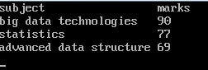

1. **Write a program in c++ to swap value of two ages of Ram and Shyam without using third variable**

**ANS:** **#include<iostream.h>**

**#include<conio.h>**

**void swap(int &age1,int &age2)**

**{**

**age2=age1+age2;**

**age1=age2-age1;**

**age2=age2-age1 ;**

**}**

**int main()**

**{**

**clrscr();**

**int age1,age2;**

**cout<<"...............................................\n";**

**cout<<"Enter two ages to be swapped:\n";**

**cou<<"................................................\n";**

**cin>>age1>>age2;**

**swap(age1,age2);**

**cout<<"..........The two numbersafterswapped..........\n";**

**cout<<"Value of age1:\n "<<age1;**

**cout<<" \n Value of age2: \n"<<age2;**

**getch();**

**return 0;**

**}**

**OUTPUT:**

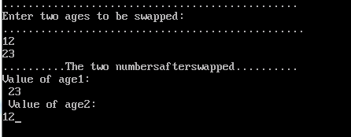

**3**.**Write a program which accepts amount as integer and display total number of Notes of Rs. 100, 50, 20, 10, 5 and 1.**

**For example, when user enter a number, 175,**

**The results would be like this...**

**100: 1**

**50: 1**

**20: 1**

**10: 0**

**5: 1**

**1: 0**

**ANS:** **#include<iostream.h>**

**#include<conio.h>**

**int main()**

**{**

**clrscr();**

**int amt,R100,R50,R20,R10,R5,R1;**

**cout<<"Enter amount \n";**

**cin>>amt;**

**R100=amt/100;**

**amt=amt%100;**

**R50=amt/50;**

**amt=amt%50;**

**R20=amt/20;**

**amt=amt%20;**

**R10=amt/10;**

**amt=amt%10;**

**R5=amt/5;**

**amt=amt%5;**

**R1=amt;**

**cout<<"Rs.100:"<<R100<<"\nRs.50:"<<R50<<"\nRs.20:"<<R20<<"\n Rs.10:"<<R10<<"\n Rs.5:"<<R5<<"\n Re.1"<<R1;**

**getch();**

**return 0;**

**}**

**OUTPUT:**

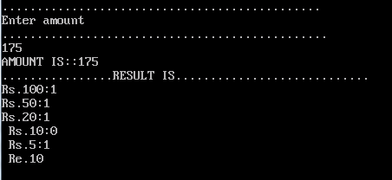

**4. Write a program which accept two T20 ODI'S averages of Mithali Raj and print their average**

**ANS:** **#include<iostream.h>**

**#include<conio.h>**

**int main()**

**{**

**clrscr();**

**int t1,t2,sum;**

**float average;**

**cout<<"................................................\n";**

**cout<<"\n ENTER TWO T20 ODIS'S AVERAGES OF MITHALI RAJ \n ";**

**cout<<".................................................\n";**

**cin>>t1>>t2;**

**sum=t1+t2;**

**average=sum/2;**

**cout<<".................................................\n";**

**cout<<"The sum of"<<t1<<" and " <<t2<<" is ::"<<sum<<" ."<<endl;**

**cout<<"The average of"<<t1<<" and "<<t2<<" is :: "<<average<<"."<<endl;**

**getch();**

**return 0;**

**}**

**OUTPUT:** 

